The Kids Vitamin Shot by Splendid Seasons Pvt Ltd is a carefully crafted functional beverage designed to support children’s daily nutritional needs and overall wellbeing. Made from a gentle blend of fruit juices, natural vitamin sources, and mild honey sweetness, this refreshing shot delivers a pleasant taste with essential nutrients in every serving. Enriched with naturally occurring vitamin C and plant-based antioxidants, it helps support normal immune function while contributing to everyday vitality and hydration. Convenient and easy to consume, the Kids Vitamin Shot is an ideal addition to a balanced daily routine, offering a simple and enjoyable way to support wellness anytime, anywhere.

Kids
Vitamin Shot




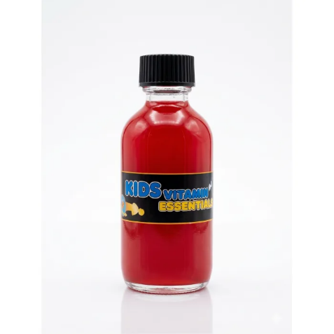
For a Serving Size of 60ml
Energy | 126 kJ / 30 kcal
Fat | 0.1g
- of which saturates | 0.02g
Carbohydrates | 6.9g
- of which sugars | 5.9g
Protein | 0.4g
Salt | 0.03g
Some of Health benefits of Kids Vitamin Shot:
- Contains vitamin C from amla and fruits, which contributes to the normal function of the immune system
- Provides natural antioxidants from beetroot and tropical fruits
- Supports general wellbeing and daily vitality
- Delivers natural energy from fruits and honey
- Contains a blend of fruits that can help support normal hydration and refreshment
Reference:
Mandal M.D., Mandal S. Honey: Its Medicinal Property and Antibacterial Activity. Asian Pacific Journal of Tropical Biomedicine. 2011.
Directions to Use for a Healthy Lifestyle:
- Take 2 bottles per day for best results
- Can be consumed in the morning or before meals
- Shake well before use.

Note:
- Do not exceed 4 bottles per day

Serving size: 60 ml

