The Gut health Shot by Splendid Seasons Pvt Ltd is a concentrated functional beverage designed to support daily digestive wellbeing. Made with bael fruit, tamarind, beetroot, ginger, cinnamon, pineapple, and honey, it delivers natural plant-based compounds in a convenient daily format.
It supports normal digestive function and provides natural energy from fruit and honey. Pineapple contributes vitamin C, which supports normal immune system function, making it a simple addition to a balanced daily routine.

Gut
Health Shot



For a Serving Size of 60ml
Energy | 108 kJ / 26 kcal
Fat | 0.1g
- of which saturates | 0.02g
Carbohydrates | 6.1g
- of which sugars | 5.1g
Protein | 0.4g
Salt | 0.03g
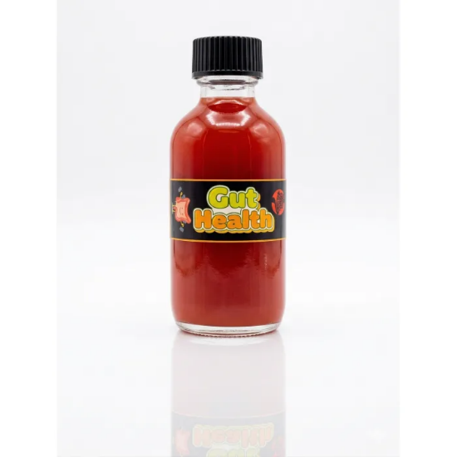

Serving size: 60 ml
Directions to Use for a Healthy Lifestyle:
- Take 2 bottles per day for best results
- Can be consumed in the morning or before meals
- Shake well before use.

Note:
- Do not exceed 4 bottles per day

Reference:
Mashhadi N.S., Ghiasvand R., Askari G., Hariri M., Darvishi L., & Mofid M.R., 2013.
Anti-oxidative and anti-inflammatory effects of ginger in health and physical activity: Review of current evidence.
International Journal of Preventive Medicine, 4(Suppl 1), S36–S42.

Some of Health benefits of Ginger Wellness Shot:
- Contains dietary fiber components from bael fruit, tamarind, and beetroot, which support normal digestive function
- Ginger contributes to normal digestion and gastrointestinal comfort
- Cinnamon contains natural antioxidant compounds
- Pineapple provides vitamin C, contributing to the normal function of the immune system
- Tamarind and bael fruit are traditionally associated with gut wellness and digestive balance
- Provides natural energy from fruit sugars and honey

