The Golden Turmeric Shot by Splendid Seasons Pvt Ltd is a concentrated functional beverage designed to support daily wellbeing and vitality. Made from turmeric, ginger, pineapple, lime, honey, and black pepper, it delivers natural plant-based compounds with antioxidant properties in a convenient daily shot.
Formulated for everyday use, it supports normal digestive function and provides natural energy from fruit and honey. Naturally occurring vitamin C contributes to normal immune system function, while black pepper enhances the bioavailability of curcumin. It is a simple, convenient wellness boost for a balanced lifestyle.

Golden
Turmeric Shot

For a Serving Size of 60ml
Energy | 99 kJ / 23 kcal
Fat | 0.1 g
- of which saturates | 0.02g
Carbohydrates | 5.4g
- of which sugars | 4.5g
Protein | 0.2g
Salt | 0.02g
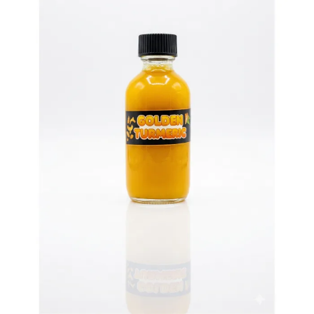



Reference:
Shoba G., Joy D., Joseph T., Majeed M., Rajendran R., Srinivas P.S. Influence of Piperine on the Pharmacokinetics of Curcumin in Animals and Human Volunteers. Planta Medica. 1998.
Some of Health benefits of Golden Turmeric Shot:
- Contains natural compounds from turmeric (curcumin) with antioxidant properties
- Ginger supports normal digestion
- Contains vitamin C from pineapple and lime, which contributes to the normal function of the immune system
- Black pepper enhances the bioavailability of curcumin
- Provides natural energy from fruit and honey
- Contains natural plant compounds that help support overall wellbeing
Directions to Use for a Healthy Lifestyle:
- Take 2 bottles per day for best results
- Can be consumed in the morning or before meals
- Shake well before use.

Note:
- Do not exceed 4 bottles per day.

Serving size: 60 ml

