The Ginger Wellness Shot by Splendid Seasons Pvt Ltd is a carefully crafted functional beverage designed to support your daily well-being. Made from a vibrant blend of pineapple juice, fresh ginger, honey, lime, and selected spices, this refreshing shot delivers a natural boost of flavor and vitality in every sip. Enriched with vitamin C and powerful antioxidants, it helps support immune function while promoting healthy digestion. Convenient and energizing, the Ginger Wellness Shot is an ideal addition to a balanced lifestyle, offering a quick and natural way to revitalize your body anytime, anywhere.

Ginger
Wellness Shot

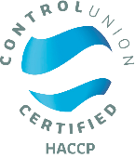
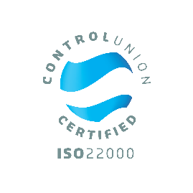
For a Serving Size of 60ml
Energy | 146 kJ / 35 kcal
Fat | 0.2g
- of which saturates | 0.03g
Carbohydrates | 7.5g
- of which sugars | 6.5g
Protein | 0.3g
Salt | 0.05g
Serving size: 60 ml
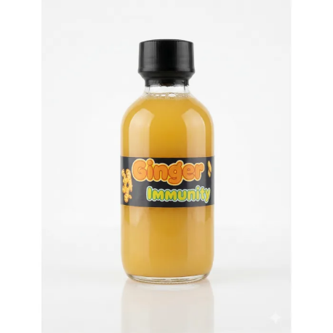
Some of Health benefits of Ginger Wellness Shot:

- Contains vitamin C which contributes to the normal function of the immune system
- Ginger supports normal digestion
- Contains natural antioxidants from spices
- Provides natural energy from honey
Reference:
Marx W., Ried K., McCarthy A., Vitetta L., Sali A., McKavanagh D., & Isenring L. Ginger (Zingiber officinale) and Its Effects on Human Health: A Systematic Review of Clinical Evidence. Food & Function. 2015.
Directions to Use for a Healthy Lifestyle:
- Take 2 bottles per day for best results
- Can be consumed in the morning or before meals
- Shake well before use.

Note:
- Do not exceed 4 bottles per day.

